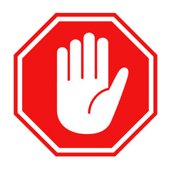
Self-Screen Prior
to Entering
- Have you tested positive for COVID in the last 10 days?
- Have you had close contact with someone with COVID in the last 10 days?
- Do you have any of these symptoms?
Fever or chills Headache
Cough New loss of taste or smell
Shortness of breath Sore throat
Fatigue Congestion or runny nose
PATIENTS
VISITORS

If you are a visitor and answered NO to all of the above questions, by entering you are confirming you do not have the above symptoms.
It is highly recommended that you mask by fully covering your nose and mouth
If you are a visitor and answered YES to any of the above questions, DO NOT ENTER
If you are a patient here for an appointment,
- It is highly recommended that you mask by fully covering your nose and mouth
- Sanitize hands
- Proceed directly to your appointment

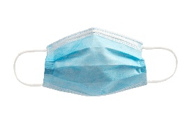

Masking is required if you are ill with any symptoms listed above.
Thank you for keeping our visitors, patients, and caregivers safe.

