COVID-19 Vaccination Event
Update
Current Phase: 1A & 1B
How: Appointment Only, Drive-Thru

- Mineral County is currently in vaccination Phase 1B. Qualification for this phase includes the following populations:
- Individuals over the age of 70
- Individuals 16-69 years old with one or more qualifying high-risk medical conditions including: Cancer, Chronic Kidney Disease, COPD (chronic obstructive pulmonary disease,) Down Syndrome, Heart conditions, such as heart failure, coronary artery disease, or cardiomyopathies, Immunocompromised state (weakened immune system) from solid organ transplant, Severe Obesity (BMI ≥ 40 kg/m2), Sickle cell disease, Type 1 & 2 Diabetes mellitus,
- Other individuals at high risk of developing severe complications including American Indians and other people of color

- If you qualify for Phase 1B and have not yet left us a message since January 20th:
- Call (406) 822-3564
- Leave a message with your name, date of birth and phone number

- We are keeping a list of names in the order requests are received. We will contact you to schedule an appointment when we have vaccine and it is your turn on the chronological list.

- We are not currently taking names for future phases of vaccine distribution.

- At this time, we are unable to confirm dates of future clinics

- For additional COVID-19 vaccination information, please refer to flyers posted at grocery stores and Post Offices, our Facebook or Instagram pages or the health department page on the county website https://co.mineral.mt.us/departments/health-department/

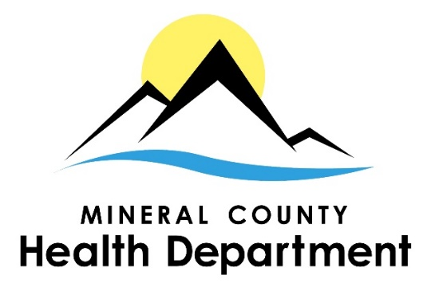
Thank you for your patience

1/26/2021

